[1.5, 0.3, 1.0]

1 run......

training 1 epoch...

26.536656141281128 seconds used......

1 training finished! average train loss: 0.7930104132084286

evaluating...

Confusion matrix, without normalization

[[ 596 0 177]

[ 282 0 148]

[ 719 0 1610]]

Normalized confusion matrix

[[0.77102199 0. 0.22897801]

[0.65581395 0. 0.34418605]

[0.30871619 0. 0.69128381]]

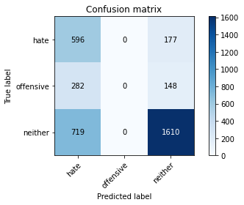

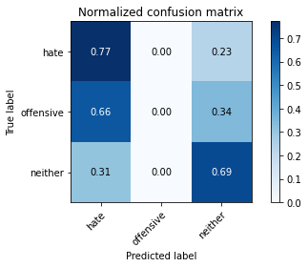

/opt/conda/lib/python3.7/site-packages/sklearn/metrics/_classification.py:1245: UndefinedMetricWarning: Precision and F-score are ill-defined and being set to 0.0 in labels with no predicted samples. Use `zero_division` parameter to control this behavior.

_warn_prf(average, modifier, msg_start, len(result))

/opt/conda/lib/python3.7/site-packages/sklearn/metrics/_classification.py:1245: UndefinedMetricWarning: Precision and F-score are ill-defined and being set to 0.0 in labels with no predicted samples. Use `zero_division` parameter to control this behavior.

_warn_prf(average, modifier, msg_start, len(result))

/opt/conda/lib/python3.7/site-packages/sklearn/metrics/_classification.py:1245: UndefinedMetricWarning: Precision and F-score are ill-defined and being set to 0.0 in labels with no predicted samples. Use `zero_division` parameter to control this behavior.

_warn_prf(average, modifier, msg_start, len(result))

precision recall f1-score support

hate 0.37 0.77 0.50 773

offensive 0.00 0.00 0.00 430

neither 0.83 0.69 0.76 2329

accuracy 0.62 3532

macro avg 0.40 0.49 0.42 3532

weighted avg 0.63 0.62 0.61 3532

average eval_loss: 0.6910558292421244, accuracy: 0.6245753114382786

training 2 epoch...

26.544219970703125 seconds used......

2 training finished! average train loss: 0.5552266855888507

evaluating...

Confusion matrix, without normalization

[[ 569 0 204]

[ 263 2 165]

[ 559 0 1770]]

Normalized confusion matrix

[[0.73609314 0. 0.26390686]

[0.61162791 0.00465116 0.38372093]

[0.24001717 0. 0.75998283]]

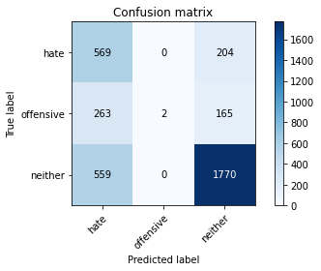

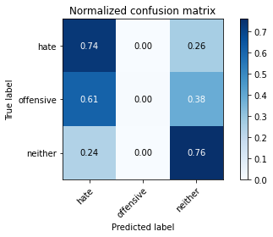

precision recall f1-score support

hate 0.41 0.74 0.53 773

offensive 1.00 0.00 0.01 430

neither 0.83 0.76 0.79 2329

accuracy 0.66 3532

macro avg 0.75 0.50 0.44 3532

weighted avg 0.76 0.66 0.64 3532

average eval_loss: 0.6495404153388772, accuracy: 0.662797281993205

training 3 epoch...

26.553473234176636 seconds used......

3 training finished! average train loss: 0.36332996803171497

evaluating...

Confusion matrix, without normalization

[[ 500 16 257]

[ 191 57 182]

[ 395 29 1905]]

Normalized confusion matrix

[[0.64683053 0.02069858 0.33247089]

[0.44418605 0.13255814 0.42325581]

[0.16960069 0.0124517 0.81794762]]

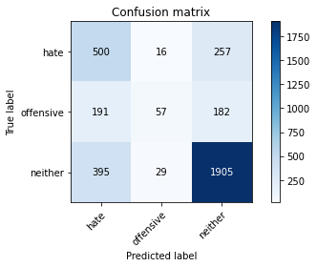

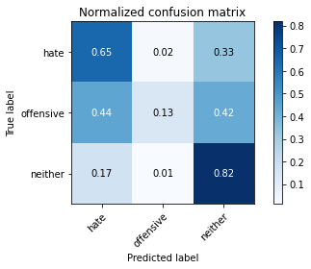

precision recall f1-score support

hate 0.46 0.65 0.54 773

offensive 0.56 0.13 0.21 430

neither 0.81 0.82 0.82 2329

accuracy 0.70 3532

macro avg 0.61 0.53 0.52 3532

weighted avg 0.70 0.70 0.68 3532

average eval_loss: 0.6935254641003528, accuracy: 0.6970554926387316

training 4 epoch...

26.539678812026978 seconds used......

4 training finished! average train loss: 0.21475147625760121

evaluating...

Confusion matrix, without normalization

[[ 443 51 279]

[ 148 110 172]

[ 286 82 1961]]

Normalized confusion matrix

[[0.57309185 0.06597671 0.36093144]

[0.34418605 0.25581395 0.4 ]

[0.12279948 0.03520824 0.84199227]]

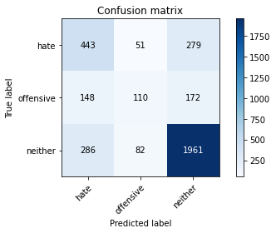

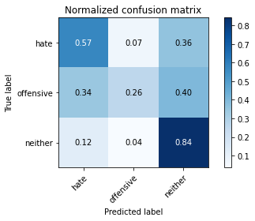

precision recall f1-score support

hate 0.51 0.57 0.54 773

offensive 0.45 0.26 0.33 430

neither 0.81 0.84 0.83 2329

accuracy 0.71 3532

macro avg 0.59 0.56 0.56 3532

weighted avg 0.70 0.71 0.70 3532

average eval_loss: 0.8800214289524461, accuracy: 0.7117780294450736

training 5 epoch...

26.524749517440796 seconds used......

5 training finished! average train loss: 0.1096749438027687

evaluating...

Confusion matrix, without normalization

[[ 423 80 270]

[ 123 144 163]

[ 296 116 1917]]

Normalized confusion matrix

[[0.54721863 0.10349288 0.34928849]

[0.28604651 0.33488372 0.37906977]

[0.12709317 0.04980678 0.82310004]]

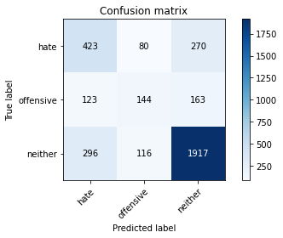

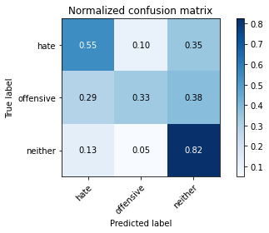

precision recall f1-score support

hate 0.50 0.55 0.52 773

offensive 0.42 0.33 0.37 430

neither 0.82 0.82 0.82 2329

accuracy 0.70 3532

macro avg 0.58 0.57 0.57 3532

weighted avg 0.70 0.70 0.70 3532

average eval_loss: 1.057578068857981, accuracy: 0.7032842582106456

training 6 epoch...

26.536638498306274 seconds used......

6 training finished! average train loss: 0.057063146573080516

evaluating...

Confusion matrix, without normalization

[[ 367 141 265]

[ 90 195 145]

[ 240 213 1876]]

Normalized confusion matrix

[[0.47477361 0.18240621 0.34282018]

[0.20930233 0.45348837 0.3372093 ]

[0.10304852 0.09145556 0.80549592]]

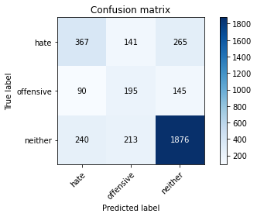

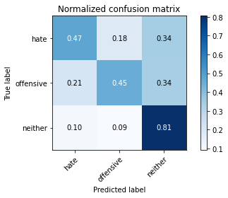

precision recall f1-score support

hate 0.53 0.47 0.50 773

offensive 0.36 0.45 0.40 430

neither 0.82 0.81 0.81 2329

accuracy 0.69 3532

macro avg 0.57 0.58 0.57 3532

weighted avg 0.70 0.69 0.69 3532

average eval_loss: 1.2614737302485832, accuracy: 0.6902604756511891

training 7 epoch...

26.50953435897827 seconds used......

7 training finished! average train loss: 0.03127267987720723

evaluating...

Confusion matrix, without normalization

[[ 375 153 245]

[ 91 211 128]

[ 249 288 1792]]

Normalized confusion matrix

[[0.4851229 0.19793014 0.31694696]

[0.21162791 0.49069767 0.29767442]

[0.10691284 0.12365822 0.76942894]]

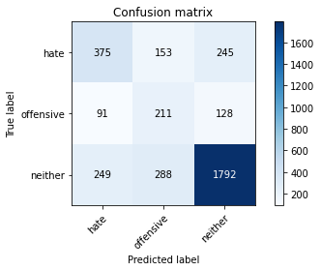

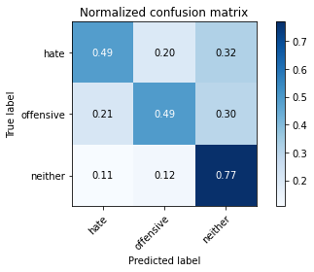

precision recall f1-score support

hate 0.52 0.49 0.50 773

offensive 0.32 0.49 0.39 430

neither 0.83 0.77 0.80 2329

accuracy 0.67 3532

macro avg 0.56 0.58 0.56 3532

weighted avg 0.70 0.67 0.68 3532

average eval_loss: 1.4740291996359152, accuracy: 0.6732729331823329

training 8 epoch...

26.589134216308594 seconds used......

8 training finished! average train loss: 0.019460565262467273

evaluating...

Confusion matrix, without normalization

[[ 412 111 250]

[ 111 186 133]

[ 291 211 1827]]

Normalized confusion matrix

[[0.53298836 0.14359638 0.32341527]

[0.25813953 0.43255814 0.30930233]

[0.12494633 0.09059682 0.78445685]]

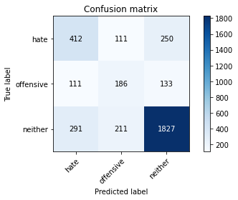

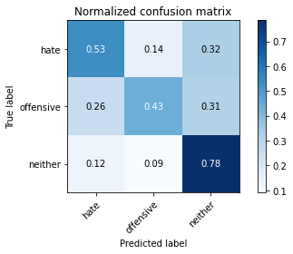

precision recall f1-score support

hate 0.51 0.53 0.52 773

offensive 0.37 0.43 0.40 430

neither 0.83 0.78 0.81 2329

accuracy 0.69 3532

macro avg 0.57 0.58 0.57 3532

weighted avg 0.70 0.69 0.69 3532

average eval_loss: 1.4943881374967973, accuracy: 0.6865798414496036

training 9 epoch...

26.540941953659058 seconds used......

9 training finished! average train loss: 0.01483445021435995

evaluating...

Confusion matrix, without normalization

[[ 389 117 267]

[ 97 186 147]

[ 258 217 1854]]

Normalized confusion matrix

[[0.50323415 0.15135834 0.3454075 ]

[0.2255814 0.43255814 0.34186047]

[0.11077716 0.09317304 0.79604981]]

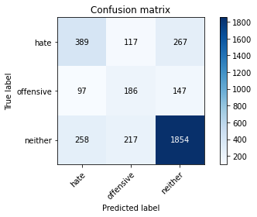

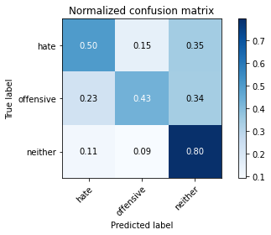

precision recall f1-score support

hate 0.52 0.50 0.51 773

offensive 0.36 0.43 0.39 430

neither 0.82 0.80 0.81 2329

accuracy 0.69 3532

macro avg 0.57 0.58 0.57 3532

weighted avg 0.70 0.69 0.69 3532

average eval_loss: 1.484114363073966, accuracy: 0.6877123442808607

training 10 epoch...

26.559265851974487 seconds used......

10 training finished! average train loss: 0.013000042501302874

evaluating...

Confusion matrix, without normalization

[[ 392 133 248]

[ 99 199 132]

[ 265 259 1805]]

Normalized confusion matrix

[[0.50711514 0.17205692 0.32082794]

[0.23023256 0.4627907 0.30697674]

[0.11378274 0.11120653 0.77501073]]

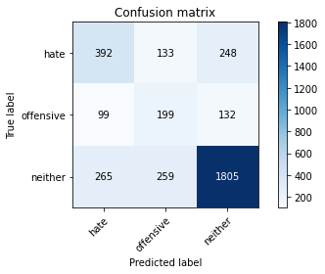

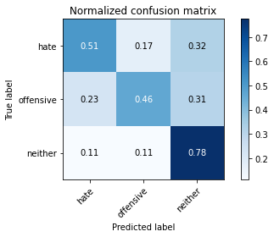

precision recall f1-score support

hate 0.52 0.51 0.51 773

offensive 0.34 0.46 0.39 430

neither 0.83 0.78 0.80 2329

accuracy 0.68 3532

macro avg 0.56 0.58 0.57 3532

weighted avg 0.70 0.68 0.69 3532

average eval_loss: 1.6647938823295851, accuracy: 0.6783691959229898

2 run......

training 1 epoch...

26.536222219467163 seconds used......

1 training finished! average train loss: 0.7796594737207189

evaluating...

Confusion matrix, without normalization

[[ 514 0 259]

[ 247 0 183]

[ 424 0 1905]]

Normalized confusion matrix

[[0.66494179 0. 0.33505821]

[0.5744186 0. 0.4255814 ]

[0.18205238 0. 0.81794762]]

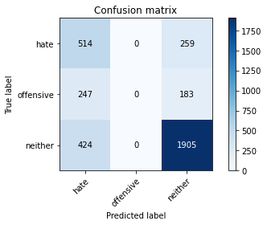

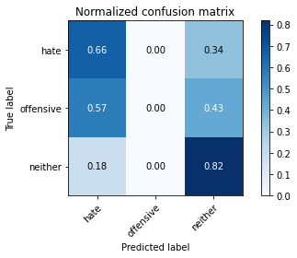

/opt/conda/lib/python3.7/site-packages/sklearn/metrics/_classification.py:1245: UndefinedMetricWarning: Precision and F-score are ill-defined and being set to 0.0 in labels with no predicted samples. Use `zero_division` parameter to control this behavior.

_warn_prf(average, modifier, msg_start, len(result))

/opt/conda/lib/python3.7/site-packages/sklearn/metrics/_classification.py:1245: UndefinedMetricWarning: Precision and F-score are ill-defined and being set to 0.0 in labels with no predicted samples. Use `zero_division` parameter to control this behavior.

_warn_prf(average, modifier, msg_start, len(result))

/opt/conda/lib/python3.7/site-packages/sklearn/metrics/_classification.py:1245: UndefinedMetricWarning: Precision and F-score are ill-defined and being set to 0.0 in labels with no predicted samples. Use `zero_division` parameter to control this behavior.

_warn_prf(average, modifier, msg_start, len(result))

precision recall f1-score support

hate 0.43 0.66 0.53 773

offensive 0.00 0.00 0.00 430

neither 0.81 0.82 0.81 2329

accuracy 0.68 3532

macro avg 0.42 0.49 0.45 3532

weighted avg 0.63 0.68 0.65 3532

average eval_loss: 0.632504904337522, accuracy: 0.684881087202718

training 2 epoch...

26.519474744796753 seconds used......

2 training finished! average train loss: 0.5488786029026789

evaluating...

Confusion matrix, without normalization

[[ 513 5 255]

[ 230 16 184]

[ 376 16 1937]]

Normalized confusion matrix

[[0.66364812 0.00646831 0.32988357]

[0.53488372 0.0372093 0.42790698]

[0.16144268 0.0068699 0.83168742]]

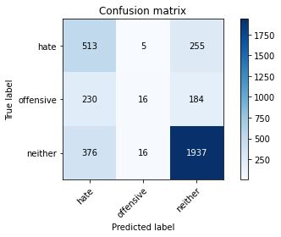

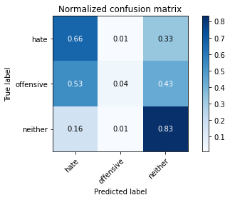

precision recall f1-score support

hate 0.46 0.66 0.54 773

offensive 0.43 0.04 0.07 430

neither 0.82 0.83 0.82 2329

accuracy 0.70 3532

macro avg 0.57 0.51 0.48 3532

weighted avg 0.69 0.70 0.67 3532

average eval_loss: 0.6099789649416498, accuracy: 0.6981879954699887

training 3 epoch...

26.519116640090942 seconds used......

3 training finished! average train loss: 0.3731640886296244

evaluating...

Confusion matrix, without normalization

[[ 513 16 244]

[ 220 46 164]

[ 384 32 1913]]

Normalized confusion matrix

[[0.66364812 0.02069858 0.3156533 ]

[0.51162791 0.10697674 0.38139535]

[0.16487763 0.0137398 0.82138257]]

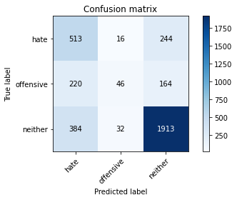

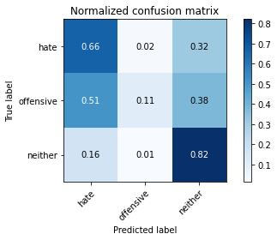

precision recall f1-score support

hate 0.46 0.66 0.54 773

offensive 0.49 0.11 0.18 430

neither 0.82 0.82 0.82 2329

accuracy 0.70 3532

macro avg 0.59 0.53 0.51 3532

weighted avg 0.70 0.70 0.68 3532

average eval_loss: 0.6768004778078047, accuracy: 0.6998867497168743

training 4 epoch...

26.52978253364563 seconds used......

4 training finished! average train loss: 0.22290138675666907

evaluating...

Confusion matrix, without normalization

[[ 470 60 243]

[ 144 137 149]

[ 307 165 1857]]

Normalized confusion matrix

[[0.6080207 0.07761966 0.31435964]

[0.33488372 0.31860465 0.34651163]

[0.13181623 0.07084586 0.79733791]]

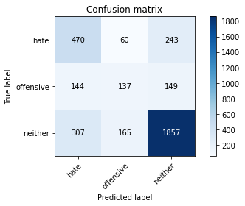

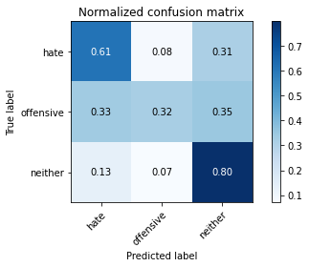

precision recall f1-score support

hate 0.51 0.61 0.55 773

offensive 0.38 0.32 0.35 430

neither 0.83 0.80 0.81 2329

accuracy 0.70 3532

macro avg 0.57 0.57 0.57 3532

weighted avg 0.70 0.70 0.70 3532

average eval_loss: 0.9139199107043487, accuracy: 0.6976217440543602

training 5 epoch...

26.500141859054565 seconds used......

5 training finished! average train loss: 0.13261471079963752

evaluating...

Confusion matrix, without normalization

[[ 430 54 289]

[ 153 121 156]

[ 249 108 1972]]

Normalized confusion matrix

[[0.55627426 0.0698577 0.37386805]

[0.35581395 0.28139535 0.3627907 ]

[0.10691284 0.04637183 0.84671533]]

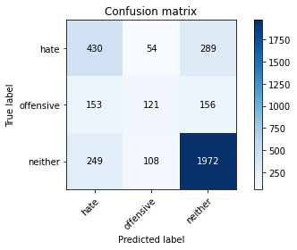

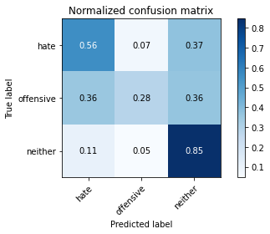

precision recall f1-score support

hate 0.52 0.56 0.54 773

offensive 0.43 0.28 0.34 430

neither 0.82 0.85 0.83 2329

accuracy 0.71 3532

macro avg 0.59 0.56 0.57 3532

weighted avg 0.70 0.71 0.71 3532

average eval_loss: 1.0681091480083384, accuracy: 0.714326160815402

training 6 epoch...

26.54751443862915 seconds used......

6 training finished! average train loss: 0.07112302873557542

evaluating...

Confusion matrix, without normalization

[[ 445 60 268]

[ 135 138 157]

[ 281 129 1919]]

Normalized confusion matrix

[[0.57567917 0.07761966 0.34670116]

[0.31395349 0.32093023 0.36511628]

[0.12065264 0.05538858 0.82395878]]

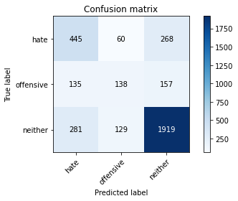

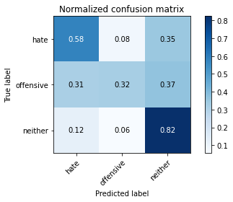

precision recall f1-score support

hate 0.52 0.58 0.54 773

offensive 0.42 0.32 0.36 430

neither 0.82 0.82 0.82 2329

accuracy 0.71 3532

macro avg 0.59 0.57 0.58 3532

weighted avg 0.70 0.71 0.71 3532

average eval_loss: 1.1681858464486181, accuracy: 0.7083805209513023

training 7 epoch...

26.51611018180847 seconds used......

7 training finished! average train loss: 0.04557868331389995

evaluating...

Confusion matrix, without normalization

[[ 404 122 247]

[ 94 187 149]

[ 266 200 1863]]

Normalized confusion matrix

[[0.52263907 0.15782665 0.31953428]

[0.21860465 0.43488372 0.34651163]

[0.11421211 0.08587377 0.79991413]]

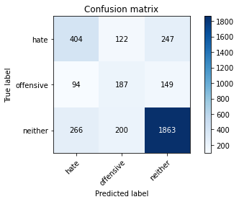

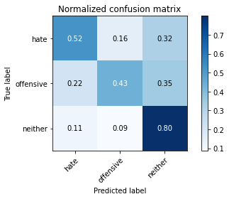

precision recall f1-score support

hate 0.53 0.52 0.53 773

offensive 0.37 0.43 0.40 430

neither 0.82 0.80 0.81 2329

accuracy 0.69 3532

macro avg 0.57 0.59 0.58 3532

weighted avg 0.70 0.69 0.70 3532

average eval_loss: 1.271964528803098, accuracy: 0.6947904869762175

training 8 epoch...

26.54722547531128 seconds used......

8 training finished! average train loss: 0.034096148068783805

evaluating...

Confusion matrix, without normalization

[[ 495 105 173]

[ 162 174 94]

[ 428 325 1576]]

Normalized confusion matrix

[[0.64036223 0.13583441 0.22380336]

[0.37674419 0.40465116 0.21860465]

[0.18376986 0.13954487 0.67668527]]

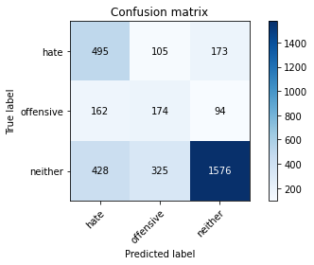

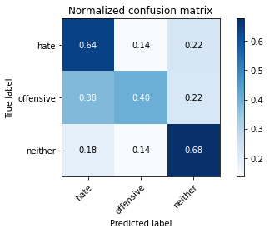

precision recall f1-score support

hate 0.46 0.64 0.53 773

offensive 0.29 0.40 0.34 430

neither 0.86 0.68 0.76 2329

accuracy 0.64 3532

macro avg 0.53 0.57 0.54 3532

weighted avg 0.70 0.64 0.66 3532

average eval_loss: 1.5084113696705823, accuracy: 0.6356172140430351

training 9 epoch...

26.580333471298218 seconds used......

9 training finished! average train loss: 0.014487236746764906

evaluating...

Confusion matrix, without normalization

[[ 394 105 274]

[ 118 164 148]

[ 227 200 1902]]

Normalized confusion matrix

[[0.50970246 0.13583441 0.35446313]

[0.2744186 0.38139535 0.34418605]

[0.09746672 0.08587377 0.81665951]]

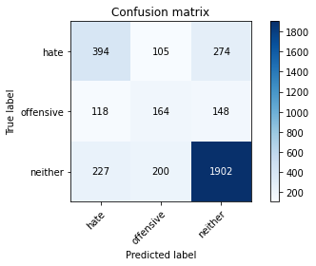

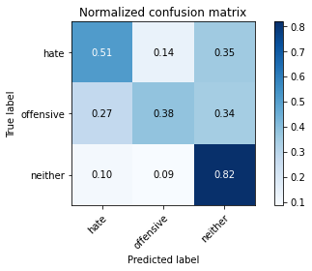

precision recall f1-score support

hate 0.53 0.51 0.52 773

offensive 0.35 0.38 0.36 430

neither 0.82 0.82 0.82 2329

accuracy 0.70 3532

macro avg 0.57 0.57 0.57 3532

weighted avg 0.70 0.70 0.70 3532

average eval_loss: 1.538652946383266, accuracy: 0.6964892412231031

training 10 epoch...

26.58482789993286 seconds used......

10 training finished! average train loss: 0.020602382830796104

evaluating...

Confusion matrix, without normalization

[[ 428 119 226]

[ 108 189 133]

[ 276 247 1806]]

Normalized confusion matrix

[[0.55368693 0.15394567 0.2923674 ]

[0.25116279 0.43953488 0.30930233]

[0.1185058 0.1060541 0.7754401 ]]

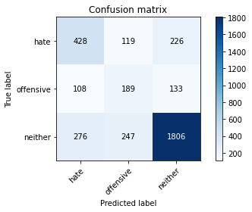

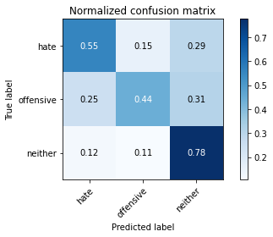

precision recall f1-score support

hate 0.53 0.55 0.54 773

offensive 0.34 0.44 0.38 430

neither 0.83 0.78 0.80 2329

accuracy 0.69 3532

macro avg 0.57 0.59 0.58 3532

weighted avg 0.71 0.69 0.69 3532

average eval_loss: 1.4958015578446415, accuracy: 0.6860135900339751

3 run......

training 1 epoch...

26.482741832733154 seconds used......

1 training finished! average train loss: 0.786653440883931

evaluating...

Confusion matrix, without normalization

[[ 363 0 410]

[ 158 0 272]

[ 205 0 2124]]

Normalized confusion matrix

[[0.46959897 0. 0.53040103]

[0.36744186 0. 0.63255814]

[0.08802061 0. 0.91197939]]

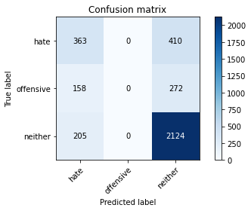

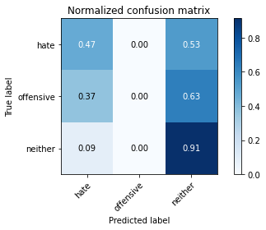

/opt/conda/lib/python3.7/site-packages/sklearn/metrics/_classification.py:1245: UndefinedMetricWarning: Precision and F-score are ill-defined and being set to 0.0 in labels with no predicted samples. Use `zero_division` parameter to control this behavior.

_warn_prf(average, modifier, msg_start, len(result))

/opt/conda/lib/python3.7/site-packages/sklearn/metrics/_classification.py:1245: UndefinedMetricWarning: Precision and F-score are ill-defined and being set to 0.0 in labels with no predicted samples. Use `zero_division` parameter to control this behavior.

_warn_prf(average, modifier, msg_start, len(result))

/opt/conda/lib/python3.7/site-packages/sklearn/metrics/_classification.py:1245: UndefinedMetricWarning: Precision and F-score are ill-defined and being set to 0.0 in labels with no predicted samples. Use `zero_division` parameter to control this behavior.

_warn_prf(average, modifier, msg_start, len(result))

precision recall f1-score support

hate 0.50 0.47 0.48 773

offensive 0.00 0.00 0.00 430

neither 0.76 0.91 0.83 2329

accuracy 0.70 3532

macro avg 0.42 0.46 0.44 3532

weighted avg 0.61 0.70 0.65 3532

average eval_loss: 0.633340193221798, accuracy: 0.7041336353340883

training 2 epoch...

26.552120685577393 seconds used......

2 training finished! average train loss: 0.5521509623264566

evaluating...

Confusion matrix, without normalization

[[ 503 0 270]

[ 247 7 176]

[ 418 7 1904]]

Normalized confusion matrix

[[0.65071151 0. 0.34928849]

[0.5744186 0.01627907 0.40930233]

[0.17947617 0.00300558 0.81751825]]

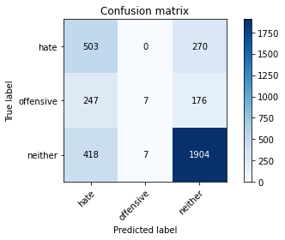

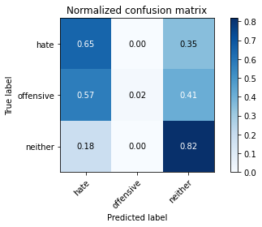

precision recall f1-score support

hate 0.43 0.65 0.52 773

offensive 0.50 0.02 0.03 430

neither 0.81 0.82 0.81 2329

accuracy 0.68 3532

macro avg 0.58 0.49 0.45 3532

weighted avg 0.69 0.68 0.65 3532

average eval_loss: 0.6164691578702065, accuracy: 0.6834654586636466

training 3 epoch...

26.521573066711426 seconds used......

3 training finished! average train loss: 0.3707933796241003

evaluating...

Confusion matrix, without normalization

[[ 510 11 252]

[ 213 51 166]

[ 364 53 1912]]

Normalized confusion matrix

[[0.65976714 0.01423027 0.32600259]

[0.49534884 0.11860465 0.38604651]

[0.15629025 0.02275655 0.8209532 ]]

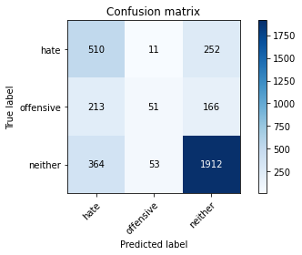

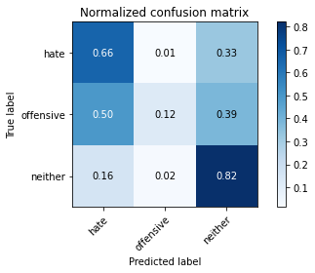

precision recall f1-score support

hate 0.47 0.66 0.55 773

offensive 0.44 0.12 0.19 430

neither 0.82 0.82 0.82 2329

accuracy 0.70 3532

macro avg 0.58 0.53 0.52 3532

weighted avg 0.70 0.70 0.68 3532

average eval_loss: 0.6792372519855445, accuracy: 0.7001698754246886

training 4 epoch...

26.544281244277954 seconds used......

4 training finished! average train loss: 0.2139823298134348

evaluating...

Confusion matrix, without normalization

[[ 463 42 268]

[ 166 100 164]

[ 307 99 1923]]

Normalized confusion matrix

[[0.59896507 0.05433376 0.34670116]

[0.38604651 0.23255814 0.38139535]

[0.13181623 0.04250751 0.82567626]]

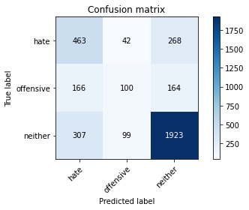

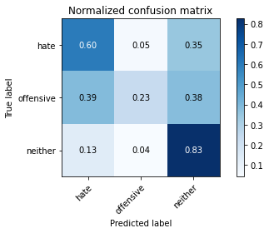

precision recall f1-score support

hate 0.49 0.60 0.54 773

offensive 0.41 0.23 0.30 430

neither 0.82 0.83 0.82 2329

accuracy 0.70 3532

macro avg 0.58 0.55 0.55 3532

weighted avg 0.70 0.70 0.70 3532

average eval_loss: 0.8297579730466261, accuracy: 0.703850509626274

training 5 epoch...

26.589476585388184 seconds used......

5 training finished! average train loss: 0.1167445774327087

evaluating...

Confusion matrix, without normalization

[[ 489 69 215]

[ 164 150 116]

[ 344 181 1804]]

Normalized confusion matrix

[[0.63260026 0.08926261 0.27813713]

[0.38139535 0.34883721 0.26976744]

[0.14770288 0.07771576 0.77458137]]

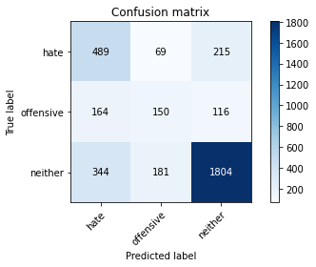

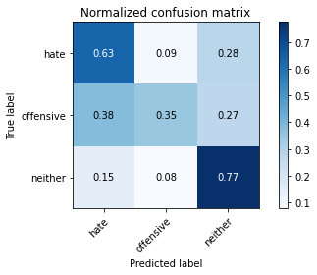

precision recall f1-score support

hate 0.49 0.63 0.55 773

offensive 0.38 0.35 0.36 430

neither 0.84 0.77 0.81 2329

accuracy 0.69 3532

macro avg 0.57 0.59 0.57 3532

weighted avg 0.71 0.69 0.70 3532

average eval_loss: 1.0512683102808429, accuracy: 0.6916761041902605

training 6 epoch...

26.490289211273193 seconds used......

6 training finished! average train loss: 0.06720709680880912

evaluating...

Confusion matrix, without normalization

[[ 387 137 249]

[ 92 215 123]

[ 211 262 1856]]

Normalized confusion matrix

[[0.50064683 0.17723157 0.3221216 ]

[0.21395349 0.5 0.28604651]

[0.09059682 0.11249463 0.79690854]]

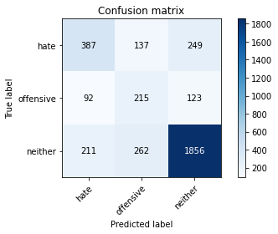

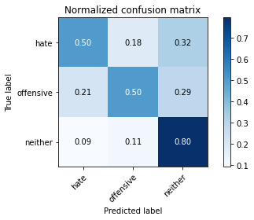

precision recall f1-score support

hate 0.56 0.50 0.53 773

offensive 0.35 0.50 0.41 430

neither 0.83 0.80 0.81 2329

accuracy 0.70 3532

macro avg 0.58 0.60 0.59 3532

weighted avg 0.71 0.70 0.70 3532

average eval_loss: 1.2611274569384796, accuracy: 0.6959229898074745

training 7 epoch...

26.56955051422119 seconds used......

7 training finished! average train loss: 0.03447777109891724

evaluating...

Confusion matrix, without normalization

[[ 493 87 193]

[ 154 159 117]

[ 403 194 1732]]

Normalized confusion matrix

[[0.6377749 0.11254851 0.24967658]

[0.35813953 0.36976744 0.27209302]

[0.17303564 0.08329755 0.74366681]]

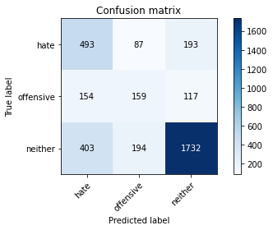

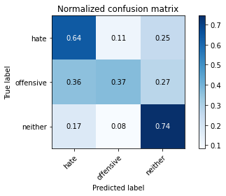

precision recall f1-score support

hate 0.47 0.64 0.54 773

offensive 0.36 0.37 0.37 430

neither 0.85 0.74 0.79 2329

accuracy 0.67 3532

macro avg 0.56 0.58 0.57 3532

weighted avg 0.71 0.67 0.69 3532

average eval_loss: 1.4095993618254608, accuracy: 0.6749716874292185

training 8 epoch...

26.546388149261475 seconds used......

8 training finished! average train loss: 0.02659108343291069

evaluating...

Confusion matrix, without normalization

[[ 416 161 196]

[ 83 245 102]

[ 275 348 1706]]

Normalized confusion matrix

[[0.538163 0.20827943 0.25355757]

[0.19302326 0.56976744 0.2372093 ]

[0.11807643 0.14942035 0.73250322]]

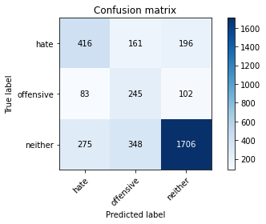

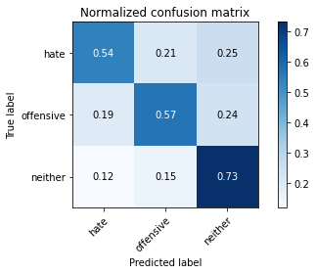

precision recall f1-score support

hate 0.54 0.54 0.54 773

offensive 0.32 0.57 0.41 430

neither 0.85 0.73 0.79 2329

accuracy 0.67 3532

macro avg 0.57 0.61 0.58 3532

weighted avg 0.72 0.67 0.69 3532

average eval_loss: 1.5916288033717096, accuracy: 0.670158550396376

training 9 epoch...

26.51442527770996 seconds used......

9 training finished! average train loss: 0.014732041051234667

evaluating...

Confusion matrix, without normalization

[[ 377 158 238]

[ 75 235 120]

[ 216 295 1818]]

Normalized confusion matrix

[[0.48771022 0.20439845 0.30789133]

[0.1744186 0.54651163 0.27906977]

[0.09274367 0.1266638 0.78059253]]

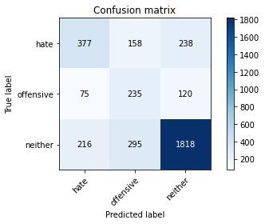

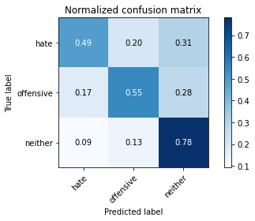

precision recall f1-score support

hate 0.56 0.49 0.52 773

offensive 0.34 0.55 0.42 430

neither 0.84 0.78 0.81 2329

accuracy 0.69 3532

macro avg 0.58 0.60 0.58 3532

weighted avg 0.72 0.69 0.70 3532

average eval_loss: 1.6389365698826515, accuracy: 0.687995469988675

training 10 epoch...

26.546013832092285 seconds used......

10 training finished! average train loss: 0.010119180754212294

evaluating...

Confusion matrix, without normalization

[[ 345 185 243]

[ 73 246 111]

[ 197 321 1811]]

Normalized confusion matrix

[[0.44631307 0.2393273 0.31435964]

[0.16976744 0.57209302 0.25813953]

[0.08458566 0.13782739 0.77758695]]

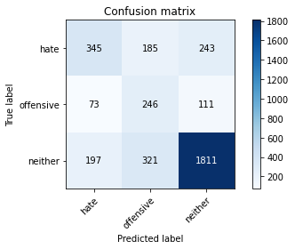

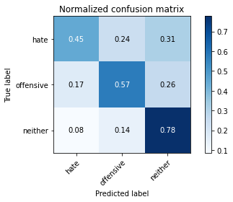

precision recall f1-score support

hate 0.56 0.45 0.50 773

offensive 0.33 0.57 0.42 430

neither 0.84 0.78 0.81 2329

accuracy 0.68 3532

macro avg 0.57 0.60 0.57 3532

weighted avg 0.71 0.68 0.69 3532

average eval_loss: 1.793564381740861, accuracy: 0.6800679501698754

4 run......

training 1 epoch...

26.5038480758667 seconds used......

1 training finished! average train loss: 0.7907922403777347

evaluating...

Confusion matrix, without normalization

[[ 430 0 343]

[ 192 0 238]

[ 322 0 2007]]

Normalized confusion matrix

[[0.55627426 0. 0.44372574]

[0.44651163 0. 0.55348837]

[0.13825676 0. 0.86174324]]

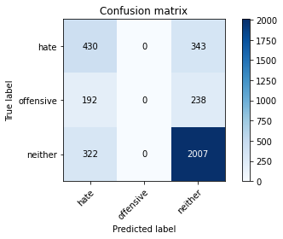

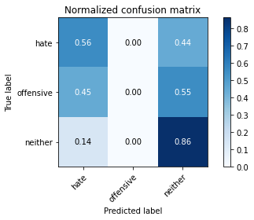

/opt/conda/lib/python3.7/site-packages/sklearn/metrics/_classification.py:1245: UndefinedMetricWarning: Precision and F-score are ill-defined and being set to 0.0 in labels with no predicted samples. Use `zero_division` parameter to control this behavior.

_warn_prf(average, modifier, msg_start, len(result))

/opt/conda/lib/python3.7/site-packages/sklearn/metrics/_classification.py:1245: UndefinedMetricWarning: Precision and F-score are ill-defined and being set to 0.0 in labels with no predicted samples. Use `zero_division` parameter to control this behavior.

_warn_prf(average, modifier, msg_start, len(result))

/opt/conda/lib/python3.7/site-packages/sklearn/metrics/_classification.py:1245: UndefinedMetricWarning: Precision and F-score are ill-defined and being set to 0.0 in labels with no predicted samples. Use `zero_division` parameter to control this behavior.

_warn_prf(average, modifier, msg_start, len(result))

precision recall f1-score support

hate 0.46 0.56 0.50 773

offensive 0.00 0.00 0.00 430

neither 0.78 0.86 0.82 2329

accuracy 0.69 3532

macro avg 0.41 0.47 0.44 3532

weighted avg 0.61 0.69 0.65 3532

average eval_loss: 0.6416840024587125, accuracy: 0.6899773499433749

training 2 epoch...

26.52943992614746 seconds used......

2 training finished! average train loss: 0.5514891835696557

evaluating...

Confusion matrix, without normalization

[[ 509 1 263]

[ 217 17 196]

[ 386 6 1937]]

Normalized confusion matrix

[[0.65847348 0.00129366 0.34023286]

[0.50465116 0.03953488 0.45581395]

[0.16573637 0.00257621 0.83168742]]

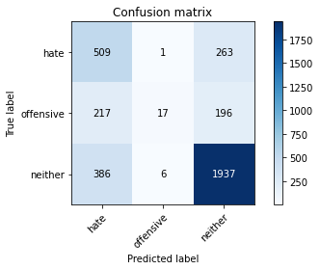

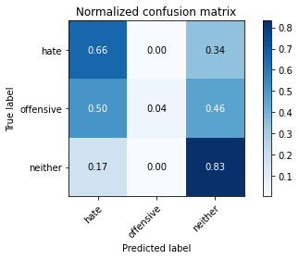

precision recall f1-score support

hate 0.46 0.66 0.54 773

offensive 0.71 0.04 0.07 430

neither 0.81 0.83 0.82 2329

accuracy 0.70 3532

macro avg 0.66 0.51 0.48 3532

weighted avg 0.72 0.70 0.67 3532

average eval_loss: 0.6181145898871503, accuracy: 0.6973386183465459

training 3 epoch...

26.549230575561523 seconds used......

3 training finished! average train loss: 0.35482256536317225

evaluating...

Confusion matrix, without normalization

[[ 424 19 330]

[ 144 70 216]

[ 220 32 2077]]

Normalized confusion matrix

[[0.54851229 0.02457956 0.42690815]

[0.33488372 0.1627907 0.50232558]

[0.09446114 0.0137398 0.89179906]]

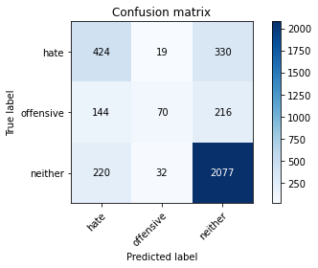

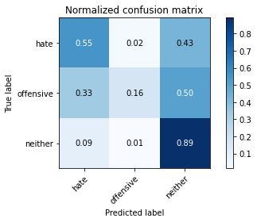

precision recall f1-score support

hate 0.54 0.55 0.54 773

offensive 0.58 0.16 0.25 430

neither 0.79 0.89 0.84 2329

accuracy 0.73 3532

macro avg 0.64 0.53 0.55 3532

weighted avg 0.71 0.73 0.70 3532

average eval_loss: 0.6776109073879355, accuracy: 0.727916194790487

training 4 epoch...

26.522979259490967 seconds used......

4 training finished! average train loss: 0.1978969374562011

evaluating...

Confusion matrix, without normalization

[[ 473 43 257]

[ 171 107 152]

[ 328 87 1914]]

Normalized confusion matrix

[[0.61190168 0.05562743 0.33247089]

[0.39767442 0.24883721 0.35348837]

[0.14083298 0.03735509 0.82181194]]

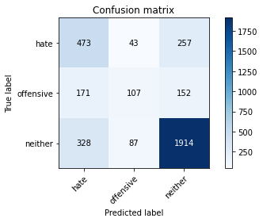

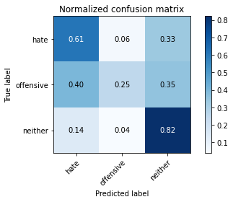

precision recall f1-score support

hate 0.49 0.61 0.54 773

offensive 0.45 0.25 0.32 430

neither 0.82 0.82 0.82 2329

accuracy 0.71 3532

macro avg 0.59 0.56 0.56 3532

weighted avg 0.70 0.71 0.70 3532

average eval_loss: 0.8717596218158297, accuracy: 0.7061155152887882

training 5 epoch...

26.53172016143799 seconds used......

5 training finished! average train loss: 0.10161204770316973

evaluating...

Confusion matrix, without normalization

[[ 465 67 241]

[ 135 154 141]

[ 330 135 1864]]

Normalized confusion matrix

[[0.60155239 0.08667529 0.31177232]

[0.31395349 0.35813953 0.32790698]

[0.14169171 0.05796479 0.8003435 ]]

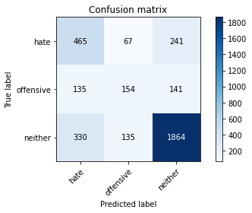

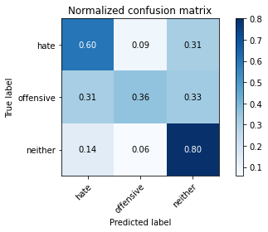

precision recall f1-score support

hate 0.50 0.60 0.55 773

offensive 0.43 0.36 0.39 430

neither 0.83 0.80 0.81 2329

accuracy 0.70 3532

macro avg 0.59 0.59 0.58 3532

weighted avg 0.71 0.70 0.70 3532

average eval_loss: 1.067702846085958, accuracy: 0.7030011325028312

training 6 epoch...

26.528061151504517 seconds used......

6 training finished! average train loss: 0.05350762868286384

evaluating...

Confusion matrix, without normalization

[[ 470 75 228]

[ 119 170 141]

[ 348 141 1840]]

Normalized confusion matrix

[[0.6080207 0.09702458 0.29495472]

[0.27674419 0.39534884 0.32790698]

[0.14942035 0.060541 0.79003864]]

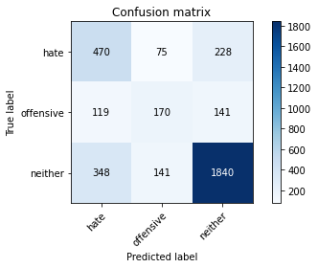

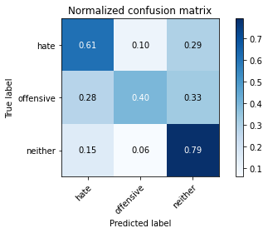

precision recall f1-score support

hate 0.50 0.61 0.55 773

offensive 0.44 0.40 0.42 430

neither 0.83 0.79 0.81 2329

accuracy 0.70 3532

macro avg 0.59 0.60 0.59 3532

weighted avg 0.71 0.70 0.71 3532

average eval_loss: 1.2201910186032792, accuracy: 0.7021517553793885

training 7 epoch...

26.538295030593872 seconds used......

7 training finished! average train loss: 0.02639103278873817

evaluating...

Confusion matrix, without normalization

[[ 414 135 224]

[ 94 210 126]

[ 272 253 1804]]

Normalized confusion matrix

[[0.53557568 0.17464424 0.28978008]

[0.21860465 0.48837209 0.29302326]

[0.11678832 0.10863031 0.77458137]]

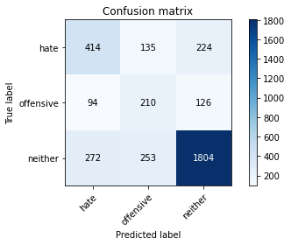

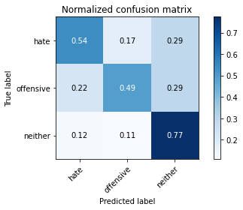

precision recall f1-score support

hate 0.53 0.54 0.53 773

offensive 0.35 0.49 0.41 430

neither 0.84 0.77 0.80 2329

accuracy 0.69 3532

macro avg 0.57 0.60 0.58 3532

weighted avg 0.71 0.69 0.70 3532

average eval_loss: 1.4075655575189214, accuracy: 0.6874292185730464

training 8 epoch...

26.60278058052063 seconds used......

8 training finished! average train loss: 0.03050582713673494

evaluating...

Confusion matrix, without normalization

[[ 382 156 235]

[ 74 232 124]

[ 237 280 1812]]

Normalized confusion matrix

[[0.49417853 0.20181113 0.30401035]

[0.17209302 0.53953488 0.28837209]

[0.10176041 0.12022327 0.77801632]]

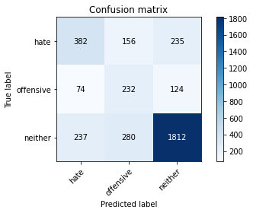

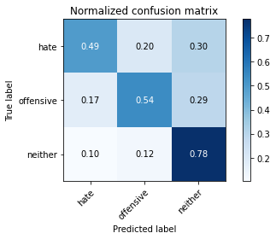

precision recall f1-score support

hate 0.55 0.49 0.52 773

offensive 0.35 0.54 0.42 430

neither 0.83 0.78 0.81 2329

accuracy 0.69 3532

macro avg 0.58 0.60 0.58 3532

weighted avg 0.71 0.69 0.70 3532

average eval_loss: 1.4934731169609026, accuracy: 0.6868629671574179

training 9 epoch...

26.56977343559265 seconds used......

9 training finished! average train loss: 0.02949358949819511

evaluating...

Confusion matrix, without normalization

[[ 426 126 221]

[ 100 232 98]

[ 284 299 1746]]

Normalized confusion matrix

[[0.55109961 0.16300129 0.28589909]

[0.23255814 0.53953488 0.22790698]

[0.12194075 0.12838128 0.74967797]]

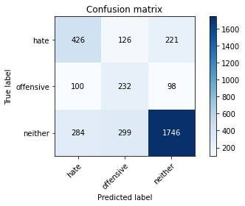

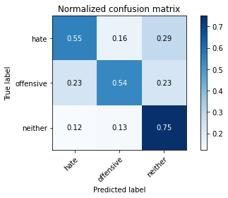

precision recall f1-score support

hate 0.53 0.55 0.54 773

offensive 0.35 0.54 0.43 430

neither 0.85 0.75 0.79 2329

accuracy 0.68 3532

macro avg 0.57 0.61 0.59 3532

weighted avg 0.72 0.68 0.69 3532

average eval_loss: 1.525713470948618, accuracy: 0.6806342015855039

training 10 epoch...

26.544677734375 seconds used......

10 training finished! average train loss: 0.029477103430990075

evaluating...

Confusion matrix, without normalization

[[ 417 109 247]

[ 98 213 119]

[ 277 234 1818]]

Normalized confusion matrix

[[0.53945666 0.14100906 0.31953428]

[0.22790698 0.49534884 0.27674419]

[0.11893517 0.10047231 0.78059253]]

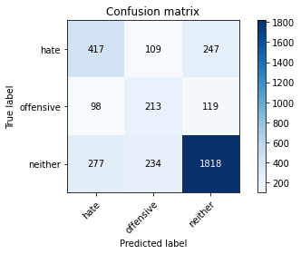

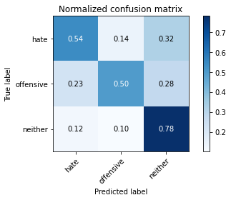

precision recall f1-score support

hate 0.53 0.54 0.53 773

offensive 0.38 0.50 0.43 430

neither 0.83 0.78 0.81 2329

accuracy 0.69 3532

macro avg 0.58 0.61 0.59 3532

weighted avg 0.71 0.69 0.70 3532

average eval_loss: 1.4962053378086306, accuracy: 0.6930917327293318

5 run......

training 1 epoch...

26.565775871276855 seconds used......

1 training finished! average train loss: 0.7950546270345941

evaluating...

Confusion matrix, without normalization

[[ 434 0 339]

[ 186 0 244]

[ 316 0 2013]]

Normalized confusion matrix

[[0.5614489 0. 0.4385511 ]

[0.43255814 0. 0.56744186]

[0.13568055 0. 0.86431945]]

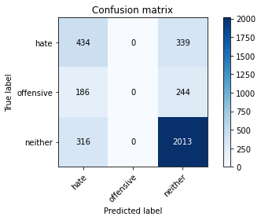

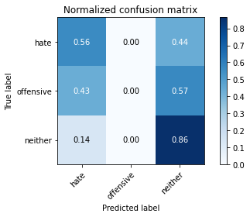

/opt/conda/lib/python3.7/site-packages/sklearn/metrics/_classification.py:1245: UndefinedMetricWarning: Precision and F-score are ill-defined and being set to 0.0 in labels with no predicted samples. Use `zero_division` parameter to control this behavior.

_warn_prf(average, modifier, msg_start, len(result))

/opt/conda/lib/python3.7/site-packages/sklearn/metrics/_classification.py:1245: UndefinedMetricWarning: Precision and F-score are ill-defined and being set to 0.0 in labels with no predicted samples. Use `zero_division` parameter to control this behavior.

_warn_prf(average, modifier, msg_start, len(result))

/opt/conda/lib/python3.7/site-packages/sklearn/metrics/_classification.py:1245: UndefinedMetricWarning: Precision and F-score are ill-defined and being set to 0.0 in labels with no predicted samples. Use `zero_division` parameter to control this behavior.

_warn_prf(average, modifier, msg_start, len(result))

precision recall f1-score support

hate 0.46 0.56 0.51 773

offensive 0.00 0.00 0.00 430

neither 0.78 0.86 0.82 2329

accuracy 0.69 3532

macro avg 0.41 0.48 0.44 3532

weighted avg 0.61 0.69 0.65 3532

average eval_loss: 0.6520884530355702, accuracy: 0.6928086070215176

training 2 epoch...

26.537811517715454 seconds used......

2 training finished! average train loss: 0.5626385402591789

evaluating...

Confusion matrix, without normalization

[[ 556 0 217]

[ 269 0 161]

[ 515 1 1813]]

Normalized confusion matrix

[[7.19275550e-01 0.00000000e+00 2.80724450e-01]

[6.25581395e-01 0.00000000e+00 3.74418605e-01]

[2.21124946e-01 4.29368828e-04 7.78445685e-01]]

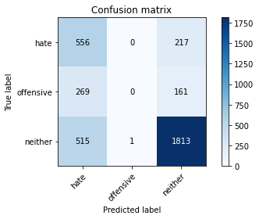

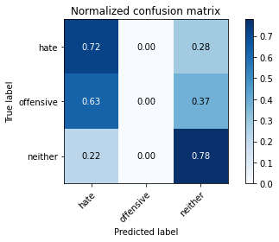

precision recall f1-score support

hate 0.41 0.72 0.53 773

offensive 0.00 0.00 0.00 430

neither 0.83 0.78 0.80 2329

accuracy 0.67 3532

macro avg 0.41 0.50 0.44 3532

weighted avg 0.64 0.67 0.64 3532

average eval_loss: 0.6218491045095152, accuracy: 0.6707248018120046

training 3 epoch...

26.517157554626465 seconds used......

3 training finished! average train loss: 0.36156841663315015

evaluating...

Confusion matrix, without normalization

[[ 550 6 217]

[ 263 27 140]

[ 484 32 1813]]

Normalized confusion matrix

[[0.71151358 0.00776197 0.28072445]

[0.61162791 0.0627907 0.3255814 ]

[0.20781451 0.0137398 0.77844568]]

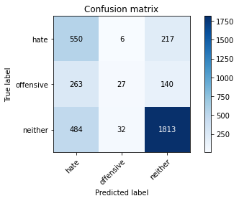

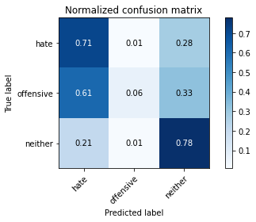

precision recall f1-score support

hate 0.42 0.71 0.53 773

offensive 0.42 0.06 0.11 430

neither 0.84 0.78 0.81 2329

accuracy 0.68 3532

macro avg 0.56 0.52 0.48 3532

weighted avg 0.69 0.68 0.66 3532

average eval_loss: 0.6975370107565896, accuracy: 0.6766704416761042

training 4 epoch...

26.564950704574585 seconds used......

4 training finished! average train loss: 0.19439413316328735

evaluating...

Confusion matrix, without normalization

[[ 464 75 234]

[ 113 171 146]

[ 324 170 1835]]

Normalized confusion matrix

[[0.60025873 0.09702458 0.30271669]

[0.2627907 0.39767442 0.33953488]

[0.1391155 0.0729927 0.7878918 ]]

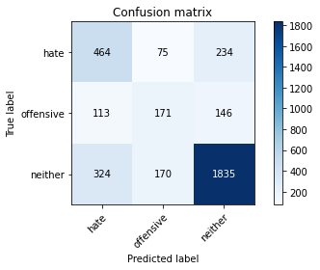

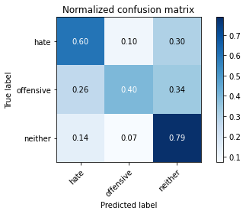

precision recall f1-score support

hate 0.51 0.60 0.55 773

offensive 0.41 0.40 0.40 430

neither 0.83 0.79 0.81 2329

accuracy 0.70 3532

macro avg 0.58 0.60 0.59 3532

weighted avg 0.71 0.70 0.70 3532

average eval_loss: 0.9457558584583681, accuracy: 0.6993204983012458

training 5 epoch...

26.495360612869263 seconds used......

5 training finished! average train loss: 0.10226042833014884

evaluating...

Confusion matrix, without normalization

[[ 485 47 241]

[ 163 122 145]

[ 369 100 1860]]

Normalized confusion matrix

[[0.62742561 0.06080207 0.31177232]

[0.37906977 0.28372093 0.3372093 ]

[0.1584371 0.04293688 0.79862602]]

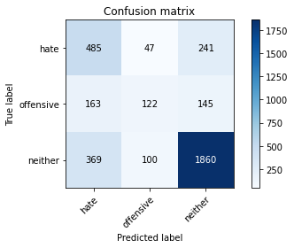

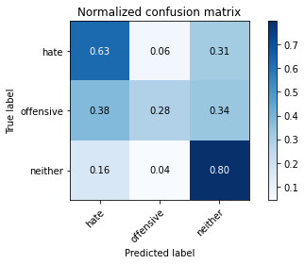

precision recall f1-score support

hate 0.48 0.63 0.54 773

offensive 0.45 0.28 0.35 430

neither 0.83 0.80 0.81 2329

accuracy 0.70 3532

macro avg 0.59 0.57 0.57 3532

weighted avg 0.71 0.70 0.70 3532

average eval_loss: 1.0824594357087787, accuracy: 0.698471121177803

training 6 epoch...

26.552667140960693 seconds used......

6 training finished! average train loss: 0.05942632853026118

evaluating...

Confusion matrix, without normalization

[[ 417 164 192]

[ 103 230 97]

[ 302 345 1682]]

Normalized confusion matrix

[[0.53945666 0.21216041 0.24838292]

[0.23953488 0.53488372 0.2255814 ]

[0.12966939 0.14813225 0.72219837]]

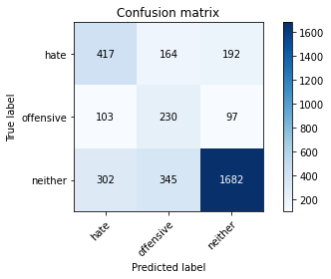

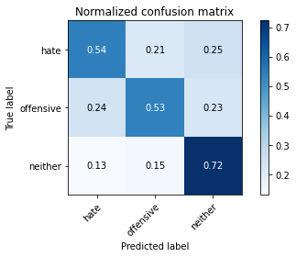

precision recall f1-score support

hate 0.51 0.54 0.52 773

offensive 0.31 0.53 0.39 430

neither 0.85 0.72 0.78 2329

accuracy 0.66 3532

macro avg 0.56 0.60 0.57 3532

weighted avg 0.71 0.66 0.68 3532

average eval_loss: 1.4653061209930538, accuracy: 0.6593997734994338

training 7 epoch...

26.517064332962036 seconds used......

7 training finished! average train loss: 0.03615405004572548

evaluating...

Confusion matrix, without normalization

[[ 417 120 236]

[ 102 203 125]

[ 268 247 1814]]

Normalized confusion matrix

[[0.53945666 0.15523933 0.30530401]

[0.2372093 0.47209302 0.29069767]

[0.11507085 0.1060541 0.77887505]]

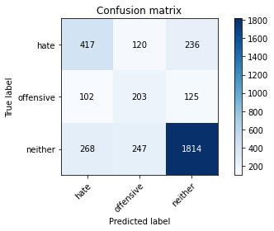

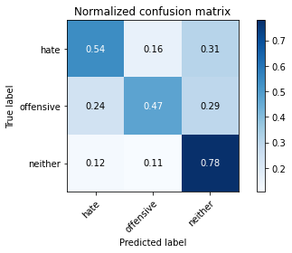

precision recall f1-score support

hate 0.53 0.54 0.53 773

offensive 0.36 0.47 0.41 430

neither 0.83 0.78 0.81 2329

accuracy 0.69 3532

macro avg 0.57 0.60 0.58 3532

weighted avg 0.71 0.69 0.70 3532

average eval_loss: 1.4229315073981796, accuracy: 0.6891279728199321

training 8 epoch...

26.537046670913696 seconds used......

8 training finished! average train loss: 0.01564400196880075

evaluating...

Confusion matrix, without normalization

[[ 419 101 253]

[ 112 183 135]

[ 272 207 1850]]

Normalized confusion matrix

[[0.54204398 0.13065977 0.32729625]

[0.26046512 0.4255814 0.31395349]

[0.11678832 0.08887935 0.79433233]]

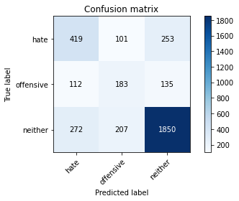

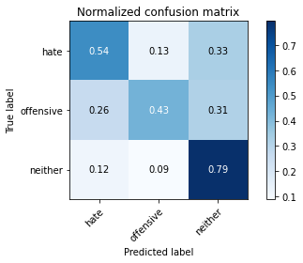

precision recall f1-score support

hate 0.52 0.54 0.53 773

offensive 0.37 0.43 0.40 430

neither 0.83 0.79 0.81 2329

accuracy 0.69 3532

macro avg 0.57 0.59 0.58 3532

weighted avg 0.70 0.69 0.70 3532

average eval_loss: 1.4764960486504992, accuracy: 0.6942242355605889

training 9 epoch...

26.529480934143066 seconds used......

9 training finished! average train loss: 0.01190094688653891

evaluating...

Confusion matrix, without normalization

[[ 393 133 247]

[ 94 221 115]

[ 250 298 1781]]

Normalized confusion matrix

[[0.5084088 0.17205692 0.31953428]

[0.21860465 0.51395349 0.26744186]

[0.10734221 0.12795191 0.76470588]]

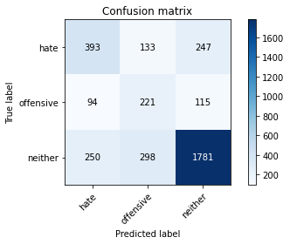

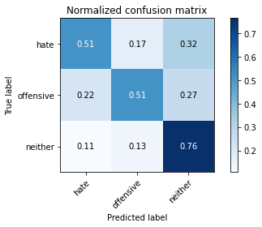

precision recall f1-score support

hate 0.53 0.51 0.52 773

offensive 0.34 0.51 0.41 430

neither 0.83 0.76 0.80 2329

accuracy 0.68 3532

macro avg 0.57 0.60 0.58 3532

weighted avg 0.71 0.68 0.69 3532

average eval_loss: 1.6648507811297468, accuracy: 0.6780860702151755

training 10 epoch...

26.559706926345825 seconds used......

10 training finished! average train loss: 0.016098099550564418

evaluating...

Confusion matrix, without normalization

[[ 365 111 297]

[ 83 186 161]

[ 201 172 1956]]

Normalized confusion matrix

[[0.47218629 0.14359638 0.38421734]

[0.19302326 0.43255814 0.3744186 ]

[0.08630313 0.07385144 0.83984543]]

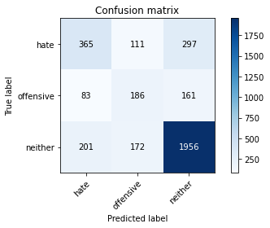

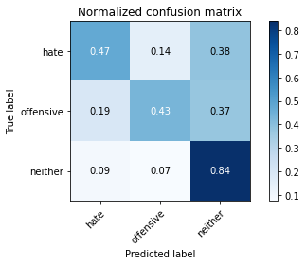

precision recall f1-score support

hate 0.56 0.47 0.51 773

offensive 0.40 0.43 0.41 430

neither 0.81 0.84 0.82 2329

accuracy 0.71 3532

macro avg 0.59 0.58 0.58 3532

weighted avg 0.71 0.71 0.71 3532

average eval_loss: 1.5190307297638623, accuracy: 0.7097961494903737